COLLEGE NAME : DON BOSCO COLLEGE (CO-ED), YELAGIRI HILLS
COLLEGE CODE : 358
DEPARTMENT : DEPARTMENT OF COMPUTER APPLICATIONS

TITLE : A CRM APPLICATION FOR THE CHAI SHOP & CO

TEAM MEMBERS NAME :

S.NO | NAME | REGISTER NUMBER
1 | ANDREWJAISON A | 35824U09008
2 | AASHISH VINOTHAN A | 35824U09001
3 | AKIN J | 35824U09004
4 | ALBERT ROSARYO F | 35824U09005
5 | ALOSHIOUS P | 35824U09006

ABSTRACT
A CRM APPLICATION FOR THE CHAI SHOP & CO
Customer relationship management plays an important role in improving customer satisfaction, maintaining customer information, and supporting business growth. However, many small food and beverage businesses still rely on manual methods such as notebooks, spreadsheets, or separate records to manage customer details, orders, and feedback. These traditional methods can lead to data duplication, information loss, calculation errors, difficulty in tracking customer history, and delays in generating useful reports.
The CRM Application for The Chai Shop & Co is designed to provide a centralized and structured system for managing customer relationships and business information. The application enables the shop to store and manage customer details, order information, purchase history, preferences, feedback, and other customer-related records in an organized manner. By maintaining the information in a centralized system, the application makes it easier to access and update customer data whenever required
The application also provides features for customer management, order tracking, feedback management, customer history, and report generation. The system helps identify regular customers, understand customer preferences, monitor purchasing patterns, and maintain better relationships with customers. A dashboard can provide useful business insights through summarized information and visual reports, helping the shop management understand customer activity and overall business performance.
By transforming manual customer management into a structured and organized CRM system, the CRM Application for The Chai Shop & Co reduces manual work, improves data accuracy, saves time, and supports efficient customer service. The system demonstrates how CRM technology can be effectively applied to a small food and beverage business to improve customer relationship management, operational efficiency, and data-driven decision-making.

PROBLEM STATEMENT
For many small food and beverage businesses, especially tea shops and cafés, customer information and sales records are still maintained manually using notebooks, paper records, spreadsheets, or separate files. While these methods may work for a small number of customers and transactions, they become difficult to manage as the number of customers and daily orders increases. Manual systems lack centralized data management and automation, which creates several operational challenges.
Some of the major problems faced in traditional systems include:
- Manual maintenance of customer information
- Data duplication and inconsistency
- Difficulty in tracking customer purchase history
- Difficulty in identifying regular and loyal customers
- Manual recording of orders and transactions
- Time-consuming report generation
- Limited customer analysis and comparison capabilities
Because of these limitations, the staff and management of The Chai Shop & Co may find it difficult to maintain accurate customer information and understand customer purchasing behaviour. Important information such as frequently purchased items, customer visit history, total purchases, and feedback may require manual checking, which increases the chances of errors. Moreover, comparing customer activity across different periods becomes complicated when records are not maintained in a structured system.
Another significant issue is the lack of centralized and easily accessible customer information. In a customer-oriented business, quick access to accurate information is important for providing better service and maintaining long-term customer relationships. However, without a proper CRM system, customer preferences, previous orders, feedback, and interaction details may not be available when required. This can lead to:

- Difficulty in providing personalized customer service
- Delayed customer follow-up
- Inaccurate customer analysis
- Reduced customer engagement
- Difficulty in identifying business trends
Additionally, traditional systems may not provide proper validation, security controls, or role-based access. This can result in unauthorized changes, data loss, duplicate records, or incomplete customer information. As the number of customers and transactions increases, maintaining historical customer data and preparing useful business reports becomes increasingly complex.
Therefore, there is a strong need for a centralized, organized, and efficient CRM Application for The Chai Shop & Co. Such a system can provide structured customer data storage, customer history management, order tracking, feedback management, automated reports, and dashboard-based insights. Implementing this solution can improve customer relationship management, reduce manual work, increase data accuracy, and support better business decision-making.
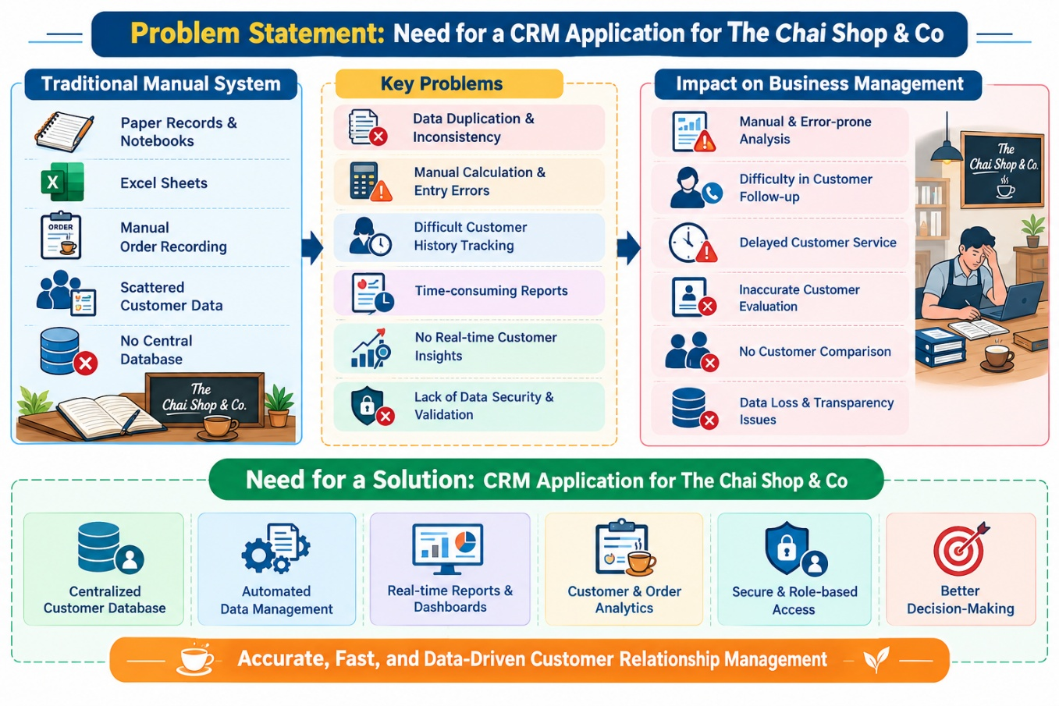
PROPOSED SOLUTION
To overcome the challenges identified in the existing customer management system, the proposed solution is the development of A CRM Application for The Chai Shop & Co. The application is designed to provide a centralized, structured, and efficient environment for managing customer information, orders, purchase history, feedback, and customer relationships.
Customer Object
This object stores important details of customers such as:
- Customer ID
- Customer Name
- Mobile Number
- Email Address
- Address
- Customer Type
- Registration Date
- Customer Preferences
- Loyalty Status
Order Management
This module captures detailed information about customer orders and transactions:
- Order ID
- Customer ID
- Order Date
- Order Items
- Quantity
- Total Amount
- Payment Status
- Order Status
The Customer and Order records are connected so that the purchase history of each customer can be maintained in an organized manner. This allows the shop management to view previous orders and understand individual customer purchasing patterns.
Feedback Management
The application also provides a structured method for maintaining customer feedback:
- Feedback ID
- Customer ID
- Feedback Date
- Rating
- Comments
- Response Status
This helps the management record customer opinions and identify areas that require improvement.
The solution also incorporates:
- Centralized Customer Database for organized information storage
- Customer History Management for tracking previous purchases
- Order Tracking for maintaining transaction records
- Feedback Management for monitoring customer satisfaction
- Search and Filter Options for quickly finding customer information
- Reports for customer and business analysis
- Interactive Dashboard for visual business insights
- Data Validation to improve accuracy
- Role-Based Access to provide secure system access
The application can generate useful reports such as regular customers, customer purchase history, order summaries, feedback reports, and customer activity. The dashboard provides summarized information that helps the management understand customer behaviour and overall business activity.
Thus, A CRM Application for The Chai Shop & Co transforms manual customer management into a centralized and organized CRM system. It reduces manual work, improves data accuracy, supports better customer service, and helps the management make informed business decisions.

WORK FLOW DIAGRAM

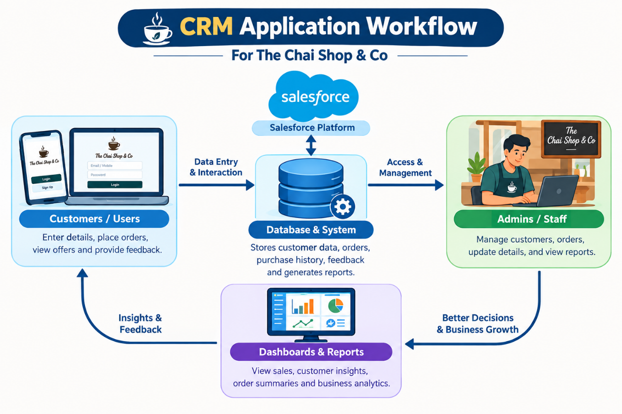

SUMMARY
The CRM Application for The Chai Shop & Co is a customer relationship management system developed to streamline the management of customer information, orders, purchase history, feedback, and business records. The system centralizes customer-related information into a structured database, making it easier to store, access, update, and manage records efficiently.
The application provides a systematic method for maintaining customer details and connecting them with their order and purchase information. This helps the management track customer history, identify regular customers, understand purchasing patterns, and provide better customer service. The centralized approach also reduces data duplication and minimizes errors associated with manual record-keeping.
Through customer management, order management, feedback management, reports, and dashboards, the application provides useful insights into customer activity and business performance. Reports and visual dashboards help the management analyze customer behaviour, order information, and overall business trends in an organized manner.
The CRM Application for The Chai Shop & Co reduces manual work, saves time, improves data accuracy, and provides easier access to important business information. It also supports secure and organized management of customer records and helps improve customer engagement.
Overall, the application demonstrates how CRM technology can be effectively used in a tea shop and food-service business to improve customer relationship management and operational efficiency. It provides a structured connection between customer data, orders, feedback, and business analysis, supporting better and more informed business management.

SCREEN SHORTS
HOME PAGE:
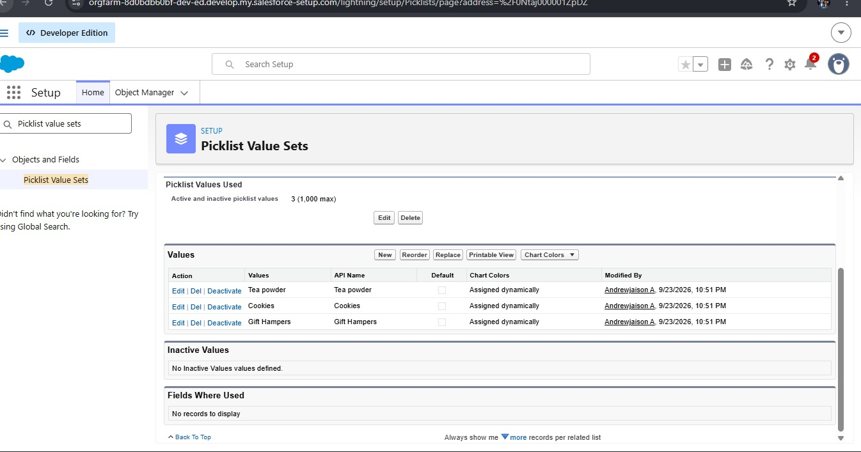
GROUP PROJECT DETAILS:
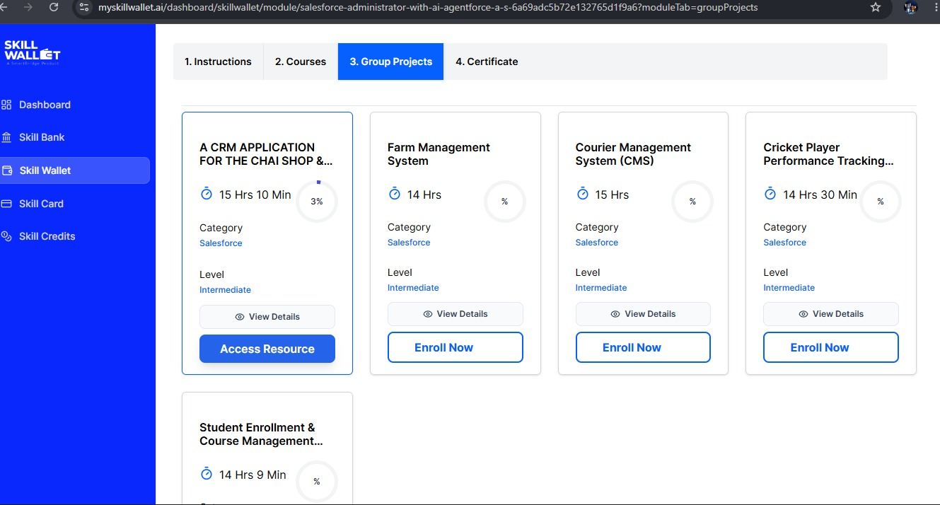
CUSTORMER ACCOUNT:
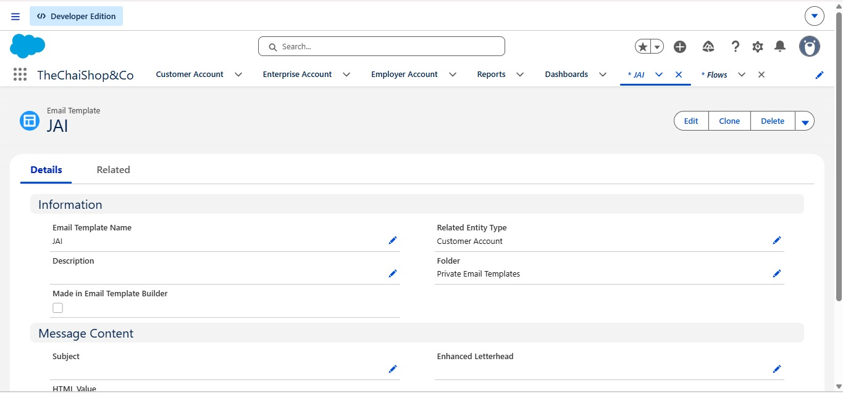
HOME:
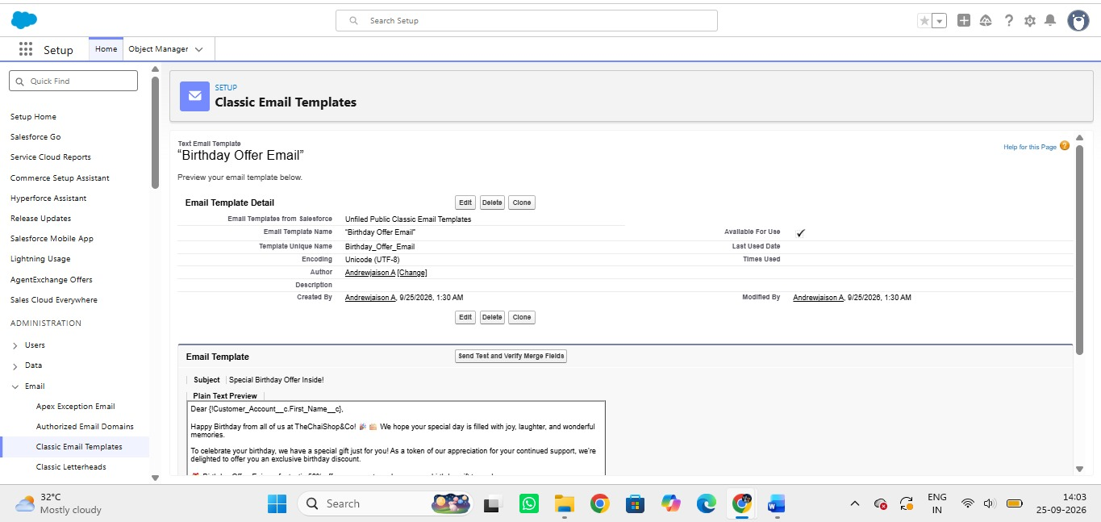
DASHBOADS:
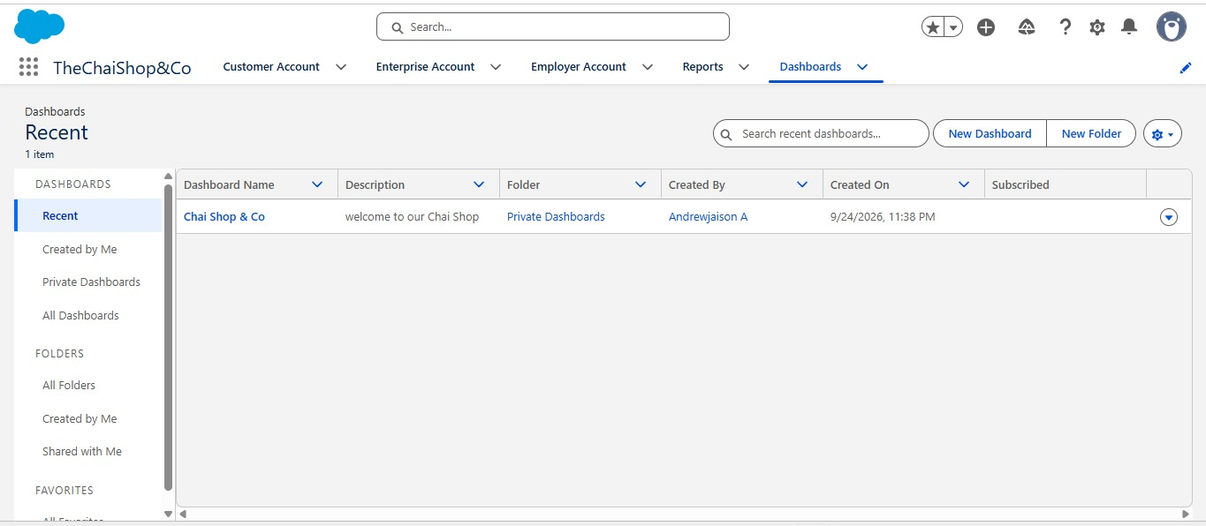
ENTERPRICE ACCOUNT:
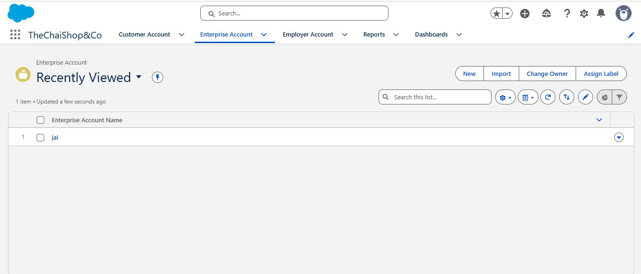

CONCLUSION
The CRM Application for The Chai Shop & Co successfully addresses the limitations of traditional customer management methods used in small food and beverage businesses. The application provides a structured and centralized approach for managing customer information, orders, purchase history, feedback, and business records.
The system provides an organized method of storing customer details and connecting them with their order and transaction information. This reduces dependency on manual record-keeping and helps minimize data duplication, errors, and loss of information. The application also makes it easier to access customer history and maintain accurate records.
The use of customer management, order management, feedback management, reports, and dashboards provides useful insights into customer behaviour and business activities. These features help the management understand customer preferences, identify regular customers, monitor orders, and improve customer service.
The CRM Application for The Chai Shop & Co improves operational efficiency by reducing manual work and saving time. It also supports better organization of customer information and provides a systematic method for generating useful reports and analysing business data.
In conclusion, this project demonstrates how a CRM-based application can be effectively used to improve customer relationship management in a tea shop and food-service business. The system provides a centralized, organized, and efficient platform that supports better customer engagement, business analysis, and informed decision-making.

